Chapter 17, Solution 63.

This is an even function.

T = 3, ω_{o} = 2π/3, b_{n} = 0.

f(t) = 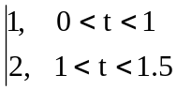

a_{o} = 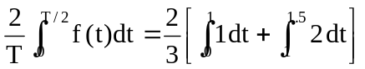 = (2/3)[1 + 1] = 4/3

a_{n} =

= 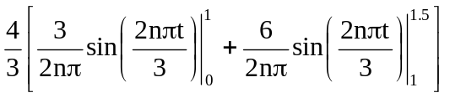

= [–2/(nπ)]sin(2nπ/3)

f₂(t) = 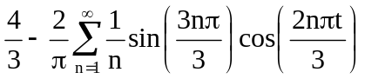

a_{o} = 4/3 = 1.3333, ω_{o} = 2π/3, a_{n} = –[2/(nπ)]sin(2nπt/3)

A_{n} = 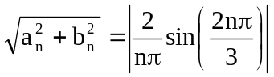

A₁ = 0.5513, A₂ = 0.2757, A₃ = 0, A₄ = 0.1375, A₅ = 0.1103

The amplitude spectra are shown below.

A_{n}
0
n
4
3
2
1
5
0.551
1.333
0.275
0
0.1103
0.1378

